FINAL DRAWING PACKAGE

Michael-Angelo Yadao, 27415559

Nicholas Cierson, 27318014

Rahul Patel, 27199708

Kostas Zoitakis, 27393741

Muhammad Haseb Ellahi, 27437579

Faraz Yunus, 27489994

Amir Shawwa, 29271627

MECH 490: Capstone Engineering Design Project

28/11/2017

**Product Specifications**

Overall dimensions of headset: 8.2 x 7.5 x 12.7 in

Overall weight: 100g (Screen) + 35g (Intel R200) + 60g (Odroid XU-4) + 428g (3d printed headset) +47g (Backpiece, Velcro) + ~330g (Fasteners, Cables) = ~1 kg

**Processor**

ODROID-XU4 chip

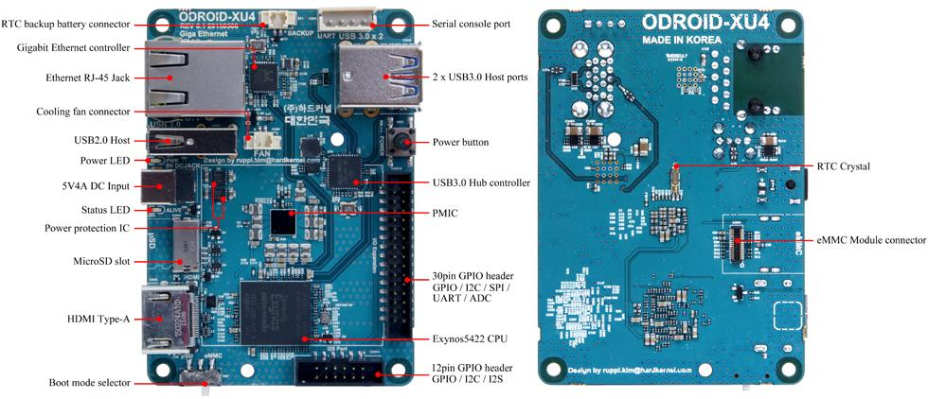

*Figure 1: ODROID-XU4 board detail, adapted from [1]*

|  |  |
| --- | --- |
| 2 x USB 3.0 | read SSD (273 MB/sec) write SSD (258 MB/sec) |
| Power input | 4.8-5.2 V (5V/4A Power supply recommended) |
| Processor | Samsung Exynos5422 ARM® Cortex™-A15 Quad 2.0GHz/Cortex™-A7 Quad 1.4GHz |
| Size/ weight | 83x58x20 mm / 38 g |
| WiFi | USB IEEE 802.11 ac/b/g/n 1T1R WLAN (external adapter) |
| Display | HDMI 1.4a |
| Software | Linux Kernel 4.9 LTS |
| Memory | 2Gbyte LPDDR3 RAM PoP (750Mhz, 12GB/s memory bandwidth, 2x32bit bus) |
| Ethernet port | Ethernet with RJ-45 Jack |

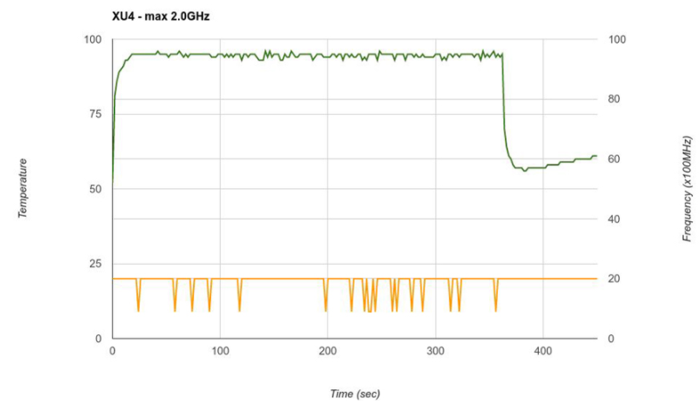

*Figure 2: ODROID-XU4 operating temperature vs running time using active cooling, adapted from [1]*

**Sensors**

Adafruit BNO055 9-DOF sensor

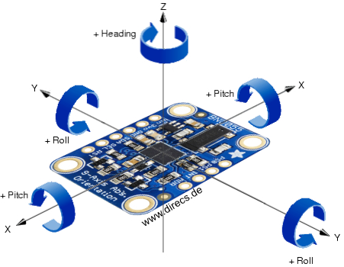

*Figure 3: BNO055 axes of rotation, adapted from [2]*

Data output [3]:

|  |
| --- |
| Absolute orientation on three axis based on a 360o sphere |
| Angular velocity on three axis rotation speed |
| Acceleration vector on three axis (gravity + linear motion) |
| Linear acceleration vector on three axis (acceleration – gravity) |
| Ambient temperature in oC |

**Intel RealSense R200 camera**

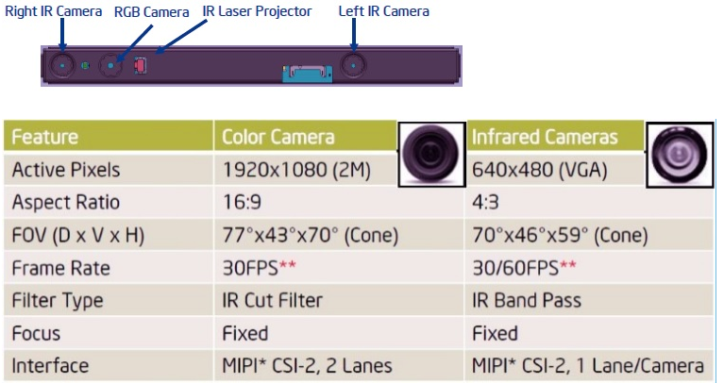

*Figure 4: R200 camera specs, adapted from [4]*

Capabilities: 3D Scanning, Speech recognition, person tracking, depth enabled photo and video, hand tracking, measurement, and scene perception.

**Display**

HDMI Display with Multitouch by ODROID

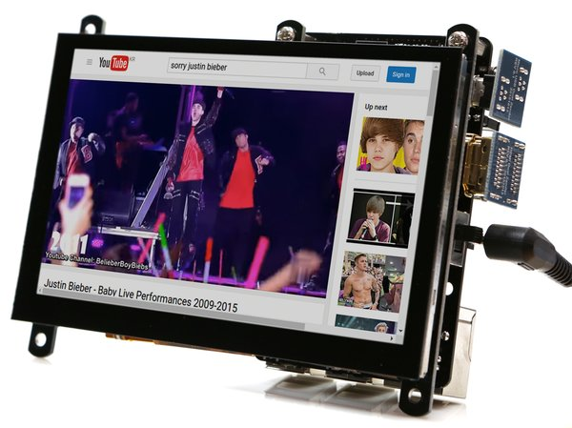

*Figure 5:* *ODROID-VU5 5 inch HDMI Display with Multitouch [5]*

|  |  |
| --- | --- |
| Screen Resolution | 800x480 pixels |
| Power Consumption | 500mA / 5V |
| Screen Dimensions | 121 x 83.31 x 15mm  (Including switch & Connectors) |
| Viewable screen size | 108 x 64 mm |
| View Angle (Deg) | Left 70, Right 70, Up 70, Down 50 |
| Weight | 100g |
| Other | TFT-LCD, 5 Finger Capacitive Touch Input, Backlight On/Off Switch |

Also includes:

* 6 x 3.5mm screws
* 3 x Hex nuts
* Micro USB link board
* HDMI link board
* Micro-to-Type A USB Cable (approx. 35cm)
* Micro-to-Micro USB Cable (approx. 35cm)
* TypeA-to-TypeA HDMI cable (approx. 35cm)

**Optics**

Clear acrylic sheet, thickness approximatively ¼ inch.

Optional: Semi-reflective, 1-way mirror film. (Inserted over the acrylic sheet)

**Significant OEM Purchases**

1. ODROID-VU5 5 inch HDMI Display with Multitouch (decided after FFF): ~55$

2. Intel RealSense R200 Camera (purchased): ~153$

3. ODROID-XU4 processor (purchased): ~120$

4. Breakout Board 9-DOF Motion Sensor BNO005 (purchased): ~63$

5. Right Angle USB 3.0 to Micro B Male cable (purchased): ~9$

6. Right Angle HDMI to HDMI cable (purchased): ~9$

7. SanDisk 32GB microSD Class UHS-I (purchased): ~20$

**Test and Safety Procedures**

The following figures are used to better explain the reader of the tests that will be performed. Please note, these figures are for reference only. For more information please refer to the midterm report for the complete test.

**Drop Test**

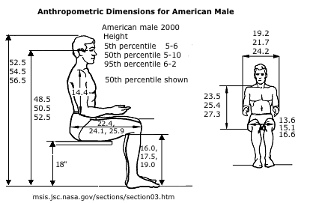

Figure 6: Heights of Males at Different Percentile [6]



Figure 7: Average Height of Counters [7]

The objective of this test is to observe what occurs to the Augmented Reality (AR) headset after it is dropped from different heights. We will be dropping the AR headset from a counter height, when the average male is sitting down, and when the average male is standing. For this test, we will be replacing the hardware with test material to replicate the weight of the individual components excluding the screen. The test will be performed in one of the MECH Labs located on the 10th floor of the H-building.

For this test, we will be following standard UL 60950-1 Standard on Information Technology Equipment Safety written by Underwriters Laboratories (UL). The drop test will show compliance to section 4.2.6 of standard UL 60950-1 (Drop Test)[8].

**Thermal Test**

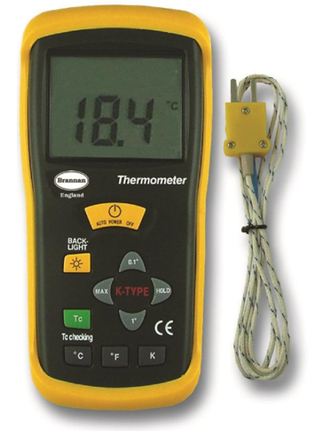

Figure 8: Thermocouple



Figure 9: Small Wind tunnel

The objective of this test is to note the operating temperature of the Augmented Reality (AR) headset. Additionally, we want to observe the air speed required to adequately bring down the temperature of the AR headset to 30 °C.

Part A of this test requires us to find the baseline temperature of the AR headset when it is operating. This is done by using a thermocouple. The second part of this test requires us to place the AR headset (at the baseline temperature) in a wind tunnel and adjust the air speed and observe the time required to bring the temperature to 30 °C. This test will take place in the Heat transfer lab (H-10) for part A as well as the Mini-capstone room (H-10) for part B.

For this test, we will be using the GR-63-Core NEBSTM standard which states the temperature limits of touchable surfaces for metals and non-metals over certain periods of time.

**Vibration Test**

The objective of this test is to observe the effects of vibration on the Augmented Reality (AR) headset. The AR headset will be subjected to different frequencies for certain periods of time in a vibration machine to see whether any of the hardware comes loose. The location and machine is yet to be determined.

**References**

[1] Hardkernel co., Ltd. “Odriod platforms.” *ODROID | Hardkernel* [Online] Available at: <http://www.hardkernel.com/main/products/prdt_info.php?g_code=G143452239825&tab_idx=2>

[2] Knapp, Autor Markus. “The Adafruit BNO055 9-DOF Sensor IMU Breakout does not make it easy - or does it?” *DIRECS*, Available at: [www.direcs.de/2017/07/der-adafruit-bno055-9-dof-sensor-imu-breakout-macht-es-einem-nicht-leicht-oder-doch/](http://www.direcs.de/2017/07/der-adafruit-bno055-9-dof-sensor-imu-breakout-macht-es-einem-nicht-leicht-oder-doch/)

[3] “Adafruit BNO055 Absolute Orientation Sensor.” *Overview | Adafruit BNO055 Absolute Orientation Sensor | Adafruit Learning System*, Available at: <https://learn.adafruit.com/adafruit-bno055-absolute-orientation-sensor/overview>

[4] “Specifications for the Intel® RealSense™ Camera R200.” *Intel*, Available at: [www.intel.com/content/www/us/en/support/articles/000016214/emerging-technologies/intel-realsense-technology.html](http://www.intel.com/content/www/us/en/support/articles/000016214/emerging-technologies/intel-realsense-technology.html)

[5] *5 inch HDMI Display with Multitouch for ODROID-VU5*, Available at: https://ameridroid.com/products/odroid-vu5-5-inch-hdmi-display-with-multitouch

[6] Msis.jsc.nasa.gov. (2017). ANTHROPOMETRY AND BIOMECHANICS. [online] Available at: https://msis.jsc.nasa.gov/sections/section03.htm [Accessed 13 Nov. 2017].

[7] Mydinette.com. (2017). Kitchen Set Buying Guide | Kitchen Sets | Bar Stools | Furniture Stores in South Jersey and Southeastern Pennsylvania. [online] Available at: https://www.mydinette.com/kitchen-set-buying-guide.html [Accessed 13 Nov. 2017].

[8] Information Technology Equipment – Safety – Part 1: General Requirements, 2nd ed. Northbrook, IL: Underwriters Laboratories, 2017, pp. 173-174.